**Could Game Mechanics Apply to Ideation in Government?  
  
*NDi content bucket: Software Development*  
*NDi* *Blog Category: Thought Leadership-Marketing & Communication***

*Tags:* *Ideation, Open Government, Collaboration, Community, Idea*

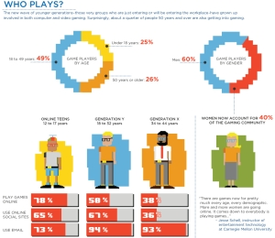

There is ample research that highlights the importance of specific motivational triggers we call rewards. We have a soft-spot for rewards – extrinsic or intrinsic – that trigger various levels of engagement. For example, the common trifecta of money, benefits and bonuses is the de facto extrinsic form of reward in most of today’s work environments.

**Source:** http://blog.socialcast.com/

There are different schools of thought, of course, but most would agree that money is a motivational force to be reckoned with (a smart motivational approach – [Zappos pays you to quit](http://www.deliveringhappiness.com/about-2/)). Still, who could live only by the “carrot-and-stick” approach? It would be a surefire approach to bland, robotic, poor quality work ethic.

Enter intrinsic or intangible rewards. The modern workplace, ensconced in a continuously withering financial landscape relies on many intrinsic—but equally fulfilling—rewards. Collaboration, participation in day-to-day decisions, peer recognition and improved morale are a few that come to mind (trust, respect and appreciation are perennial tenets).  
  
The question becomes what specific intrinsic rewards could possibly bolster meaningful engagement, innovation, collaboration, etc. in Government?

**“Lets play a game”**

Games and their mechanics provide a great rewards-based blueprint that Open Government and [ideation/innovation](http://www.whitehouse.gov/open/innovations) in Government can use. Game mechanics incorporate smart rewards such as ratings, farm coins, points, badges, levels, flare, etc. to quench gamers’ and players’ thirst for rewards. Government employees, especially younger govies rapt in gaming, would [jump for joy](http://www.supermario.com/) were they able to use game mechanics and rewards to improve their workplace.

As a large swath of the federal government workforce moves into retirement, younger employees will assume additional responsibilities and play larger roles in their organizations.

At NDi, we try to engage users to “earn” game points for ideas that inspire conversation, and reward users for carrying conversations that expand ideas. Meanwhile, users level up their own skills through community building and collaboration. That’s the approach we try to follow when we help clients develop and deploy social media-like tools. The result is increased user engagement and wider crowdsourcing and collaboration.

Sources:

http://mashable.com/2010/07/13/game-mechanics-business/

http://en.wikipedia.org/wiki/Game_mechanics

http://www.whitehouse.gov/open/innovations